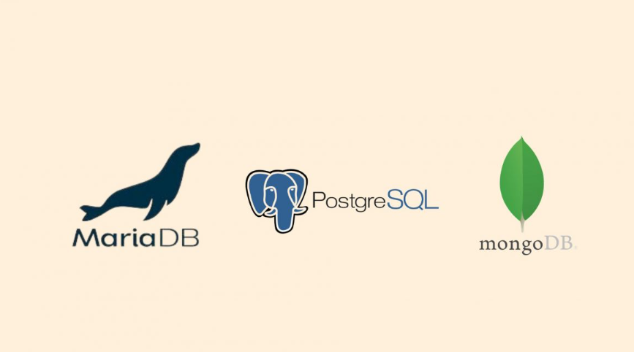

mangoDB : <https://www.mongodb.com/fr-fr/pricing>

[**MongoDB**](https://www.mongodb.com/) is a cross-platform document-oriented database. Its a specialized DB build on non-relational document store architecture similar to JSON+ and support any type of file or elements. It offers higher speed of processing data and less response time for some specified application.

postgreSQL : <https://www.postgresql.org/>

[**PostgreSQL**](https://www.postgresql.org/) is an alternative to MySQL working on ORDBMS (Object-Relational Database Management System). As a database server, its primary function is to store data, securely and supporting best practices, and retrieve it later, as requested by other software applications, be it those on the same computer or those running on another computer across a network. The said architecture has many advantages over [MySQL](https://www.mysql.com/) in areas of performance and redundancy.

MariaDB :<https://mariadb.org/documentation/>

[**MariaDB**](https://mariadb.org/) is considered as the fork(replica) of MySQL database. It was developed by the same developer as that of MySQL except for the fact MariaDB offers many more additional functionalities to the MySQL engine.

| Fonctionnalités | MariaDB | MongoDB | PostgreDB |
| --- | --- | --- | --- |
| Prix | gratuit | payant | gratuit |
| LA BASE | MariaDB est un système de base de données originaire de MySQL.  Toutes les commandes, interfaces,  librairies et API de MySQL existent dans MariaDB | MongoDB is the non-relational database system most popular lately, because of the promptness and flexibility offered to your developments. It uses a syntax similar to JSON and supports the storing of any type of elements: objects, physical files, etc. | It’s the free alternative to MySQL, counting on scalability and versatility levels that are very similar. Remarkable for its strength. |
| Type de base | RDBMS :  Relational Database Management system.  La base est créée dans un format de table | Document :  La base est sous forme de document | RDBMS :  Relational Database Management system.  La base est créée dans un format de table |
| types de données supportées | BLOB  binary large object | BSON  JSON  All MySQL  DECIMAL  Floating | BLOB  binary large object |
| Langage des requêtes | SQL | API calls  Javascript  REST | SQL |
| Modèles de réplication | Maître-esclave  Maître-Maître  Multisource | Maître-esclave | Maître-esclave |
| Index | B-tree  Hash  R-Tree | B-tree  Hash  GiST  GIN | Default _id  Single Field  Compound Index  Multikey Index  Geospatial Index  Text Indexes  Hashed Indexes |
|  |  |  |  |
| langages supportés | Ada  C  C#  C++  D  Eiffel  Erlang  Haskell  Java  Objective-C  OCaml  Perl  PHP  Python  Ruby  Scheme  Tcl | Actionscript  C  C#  C++  Clojure  ColdFusion  D  Dart  Delphi  Erlang  Go  Groovy  Haskell  Java  JavaScript  Lisp  Lua  MatLab  Perl  PHP  PowerShell  Prolog  Python  R  Ruby  Scala  SmalltalkSmalltalk | .Net  C  C++  Java  Perl  Python  Tc |

User manual :

Type Visual Studio Code and click on Download under <https://code.visualstudio.com/> :

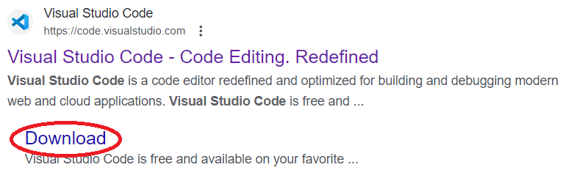

Select the correct version for your OS : 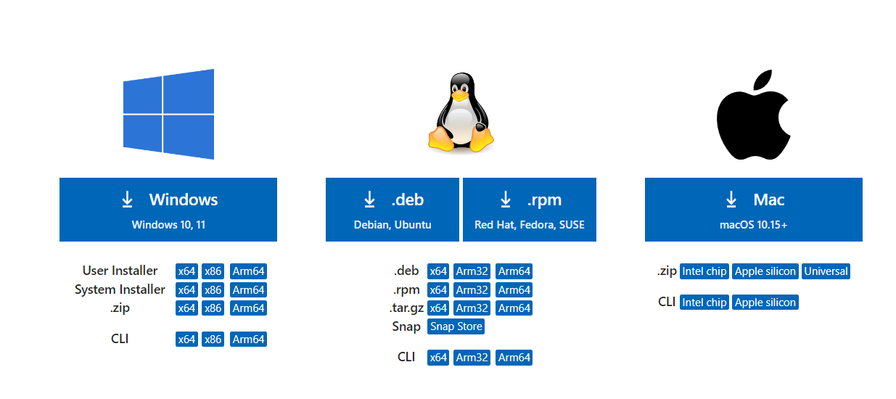

Start the .exe downloaded.

accept the conditions :

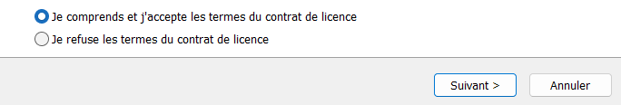

Press next 2 times, choose the folder for the installation and press install.

Press finish.

VS code should be installed and opened.

Once you are on VS Code, go to extension :

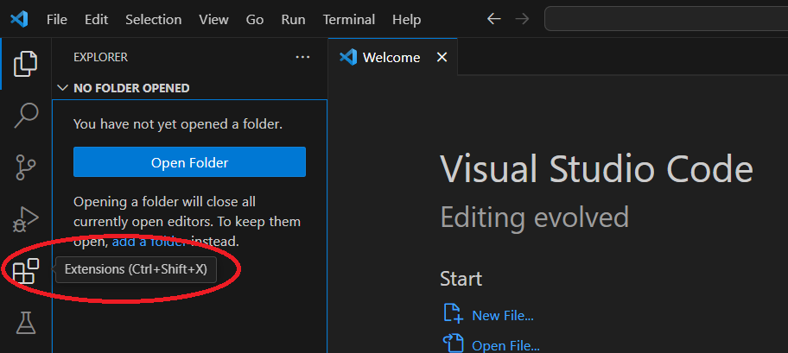

Then, type PHP and install the first extension : 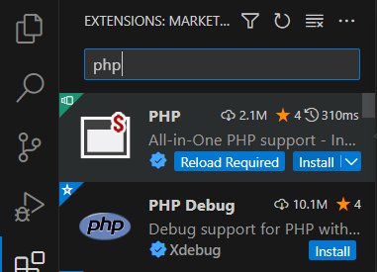

Congratulation, you can now create a new .php file !